

A Report on

*Multipurpose Rack Using Cantilever Mechanism*

Submitted by

*Mehul Patil (Roll No.-305)*

*Niranjan Patil (Roll No.-307)*

*Shweta Sadwani (Roll No.-316)*

*Shreyas Sanghai (Roll No.-319)*

*Pooja Sawant (Roll No.-322)*

**Course Code**: ET206

**Course**: Mechanical Prototyping

**Faculty:** Mr. A. S. Chandore

**Block:** B3 **Branch: Computer** Engineering

**Batch:** A1 **Group No.:**  *3*

**Dates:** 12st Sep 2017 to 20th Sep 2017

**Cycle:** 2 **Round:** 1

**Year: 2017 – 18**

|  |  |  |
| --- | --- | --- |
| Examiner – 1 (External ) | Name: | Sign and Date: |
| Examiner – 2 (Internal) | Name: A. S. Chandore | Sign and Date: |

**2. Introduction:**

Prototyping is the concept which allows engineers and designers to explore the design alternatives with the help of modeling software. Prototype is an early sample of the actual idea of the design. Designer and engineers can test the model or they can test the performance of the model by the use of concept of prototyping. It is the initial step between actual manufacturing of idea and the evaluation of the idea. Thus, for mechanical part manufacturing most commonly used technology is Rapid Prototyping. By the use of Rapid Prototyping, the idea can be first designed on the CAD software and then with the help of kisslicer and cura software the orientation is given to the 3D model and the part is then manufactured under the computer control 3D printing machine.

**2.1 Advantages:**

1. Main Advantages is any shape can produce

2. Saving 50 to 90 % time any money as compared to conventional system.

3. Material waste is reduced.

4. Assemblies can be made in one go.

5. Error can be detected at early stages.

6. No tooling is necessary.

**2.2 Limitations:**

1. The price of machinery and material is expensive.
2. The strength of RP parts are weaker in Z direction than in other
3. The surface is usually rougher than machined surface

**2.3Techniques of Rapid prototyping:**

1. **Stereo lithography (SLA) :**

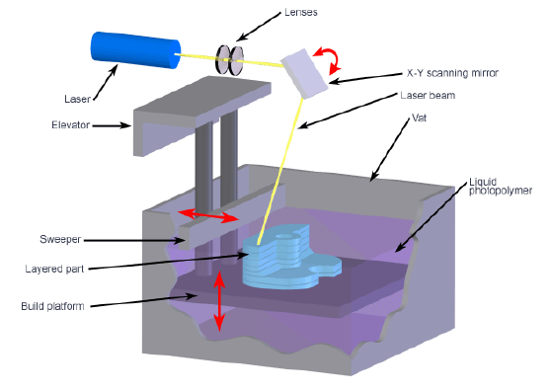

SLA uses a liquid polymer substance to print in 3D

SLA exposes the liquid polymer to ultra violet light which hardens the polymer. The polymer substance starts as a liquid in vat and then is exposed to the ultra violet light curing the substance one layer at a time. Once the photopolymer has been exposed to the light enough times; the design is removed from the liquid and covered with a protective layer.

1. **Fused deposition modeling (FDM):**

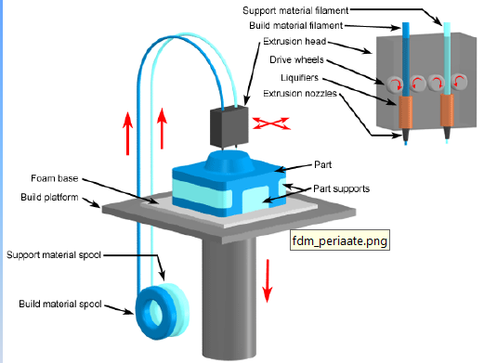

In FDM process plastic or wax material is extruded through nozzle that traces the part cross sectional geometry layer by layer. The ABS, Polycarbonate and elastomer material used in FDM process.

1. **Selective laser sintering (SLS):**

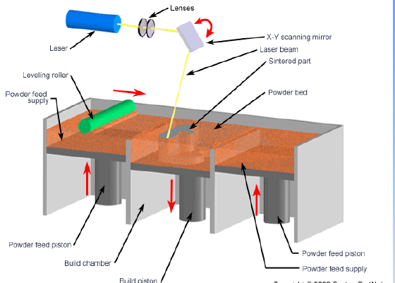

Sintering is the process of heating up a powdery substance without it reaching the point of melting and yet still aloe the particle to bond together ,creating coherent mass, metallic plastic, ceramic or glass powder are used in the SLS process while a high powdered laser (a carbon dioxide laser for example) is directed at the particle to fuse the material together. A layer of desired substance is laid down and then laser is guided by the CAD design. Once the laser has focused on the desired areas another layer of powder is added. This is repeated until the design is finished.

**4**. **Laminated object manufacturing:**

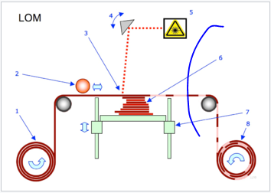

In that process, layers of adhesive-coated Paper, plastic or metal laminates are successively glued together and cut to shape with a knife or laser cutter. Objects printed with this technique may be additionally modified by machining or drilling after printing. Typical layer resolution for this process is defined by the material feedstock and usually ranges in thickness from one to a few sheets of copy paper.

The laminated object manufacturing process is performed as follows:

1. Sheet is adhered to a substrate with a heated roller.
2. Laser traces desired dimensions of prototype.
3. Laser cross hatches non-part area to facilitate waste removal.
4. Platform with completed layer moves down out of the way.
5. Fresh sheet of material is rolled into position.
6. Platform downs into new position to receive next layer.
7. The process is repeated.
   1. **3D printing:**

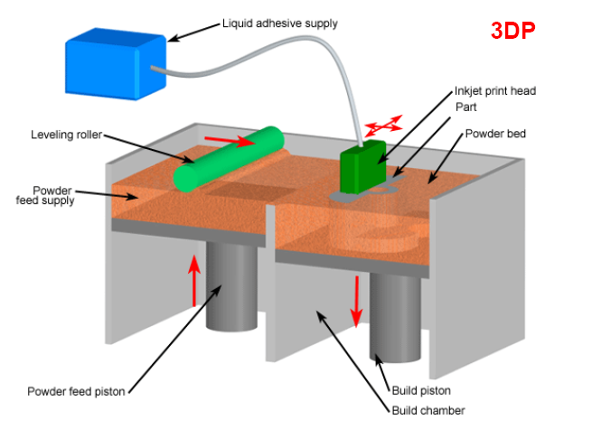

In 3D printing process, an ink jet printing head deposits a liquid adhesives that binds the material. 3D printing process is quiet fast 2-4 layers per minute.

At the end the part is infiltrated with sealant to improve strength and surface finish.

**6. Direct metal laser sintering (DMLS):**

Direct Metal Laser Sintering (DMLS) is a powder-bed additive manufacturing technology that doesn’t require any tooling and is referred to as SLS (selective laser sintering) or SLM (selective laser melting). The process involves creating metal parts with simple to complex geometries directly from a 3D CAD (computer aided design) file. The DMLS software will then instruct the 3d printer to build the metal part or object layer by layer (between 20-40 microns thick) by fusing metal powder into a solidified state through a directional or focused laser beam.

One advantage of the DMLS as compared to SLS is the small size of the particle which enables much desired parts.

**3. Concept presentation:**

We see that, a rack requires a lot of space and racks is in fix position but our product is adjustable using cantilever mechanism.

**4. CAD modeling**

**a.project**

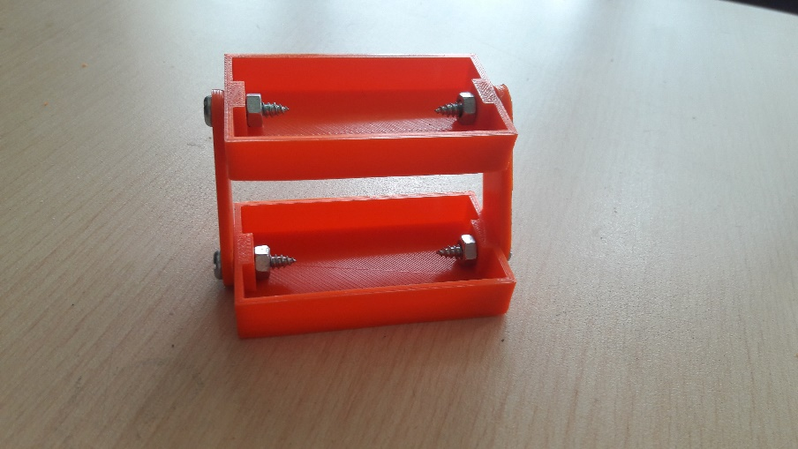

**b. group assembly with parts**

**5. Methodology:**

**5.1. Pre processing**

In this method, the software used are CAD software, Kisslicer, cura, etc. First the idea of model is being designed with the help of CAD software and in this software various commands are used as follows: Pad command, Extrude command, hole command, pattern command, etc.

After the modeling done on CAD software, the file is saved in (“.stl “) format because (. stl) format is only suitable for Kisslicer and cura software. Then the model is get sliced into different layers in Kisslicer software so, Kisslicer helps to manufacture the model by layered formation. Designer can decide the style which is to be given to the 3D model like layer thickness, support thickness, amount of material to be filled in the model, etc. Then, cura software converts the (.stl) file into (.gcode) which is only acceptable by 3D printer.

**CAD Software: Autodesk Fusion 360**

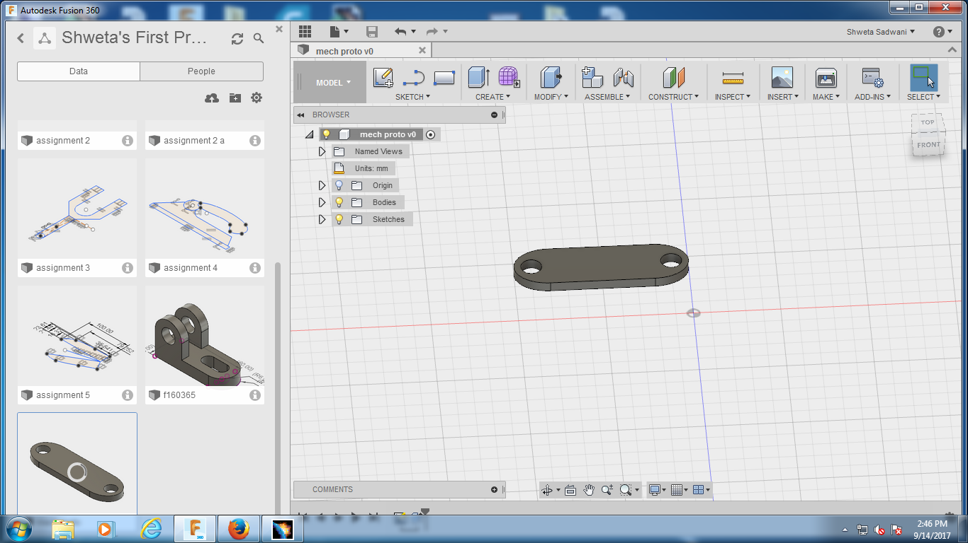



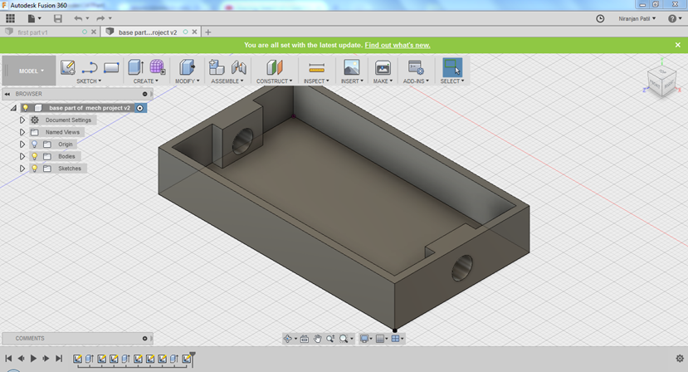



**3D printer Software: Cura**

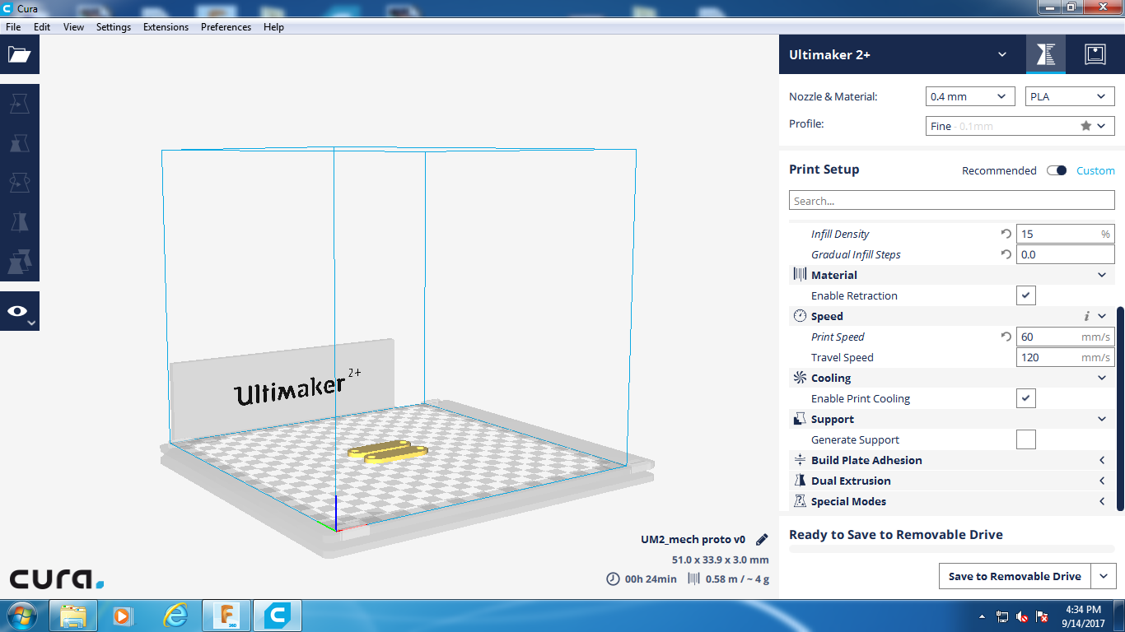

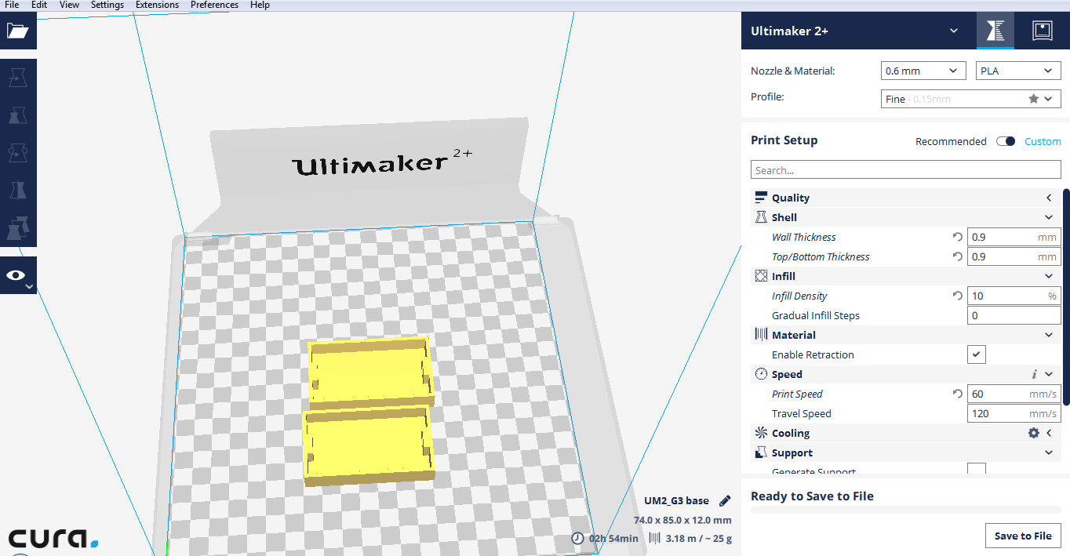

**3D printer Software: Kisslicer**

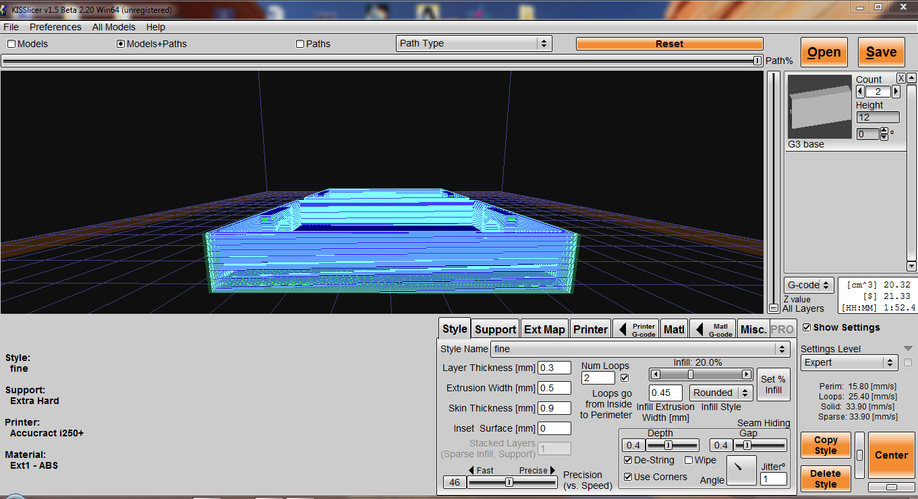

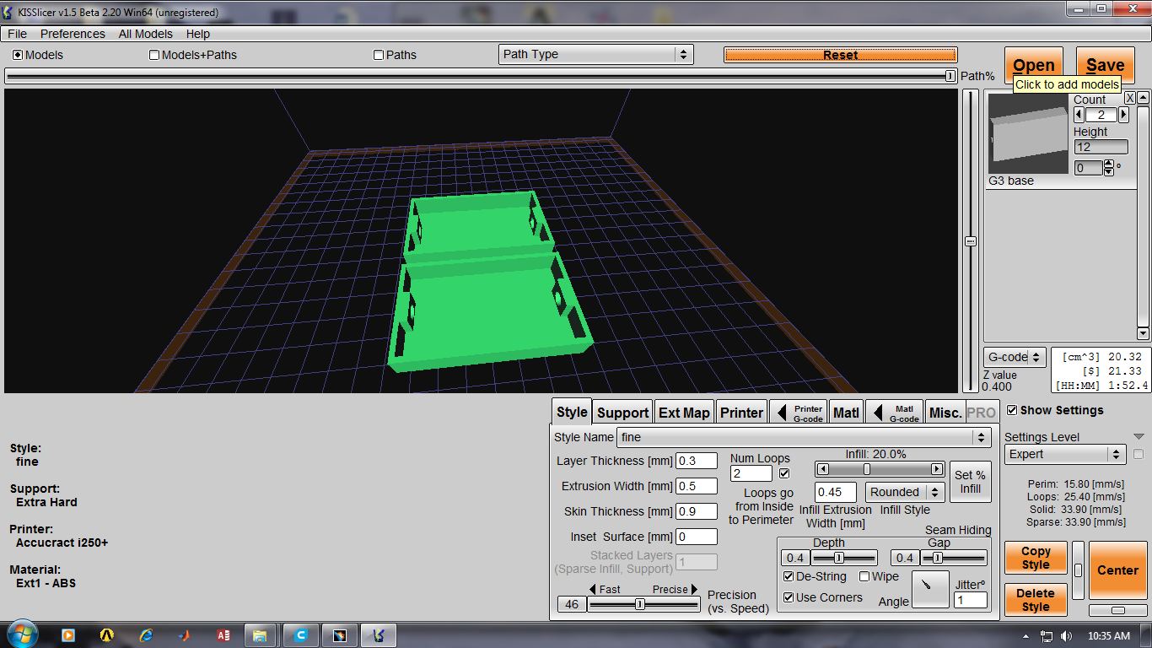

**3D printer Software: Repetier**

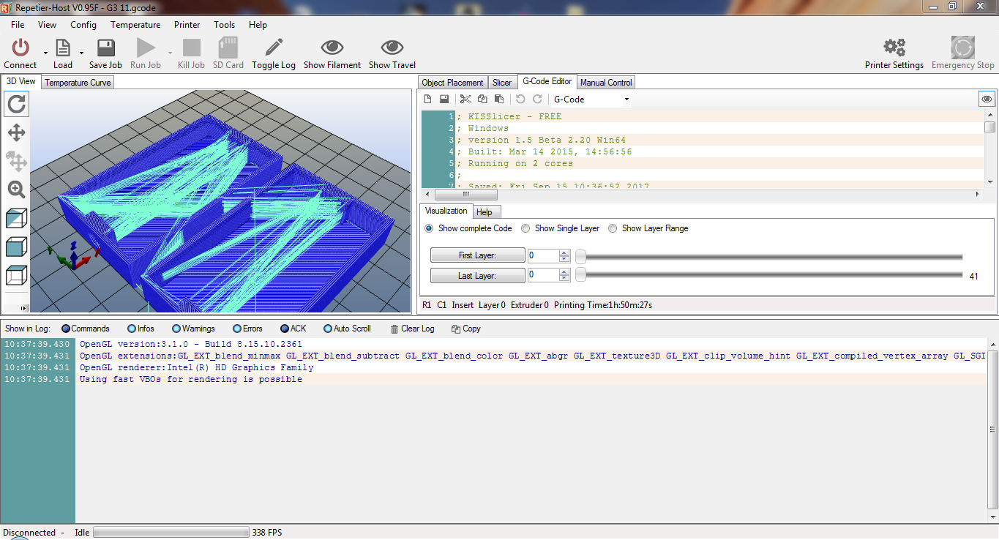

**5.2 Processing:**

In this method actual 3D printing takes place, there are various types of processes for 3D printing but the most commonly used is FDM (fused deposition modeling).It is developed by Stratasys. The material used for FDM is ABS (Acrylonitrile butadiene styrene). It is a thermoplastic polymer. FDM is slow in processing as compared to stereo lithography (SLA) and selective laser sintering (SLS). FDM have properties like heat resistance, strength, Rigidity, Stability, and surface of model made may be rigid. In this process support is created as waste product which is removed by filing or finishing.

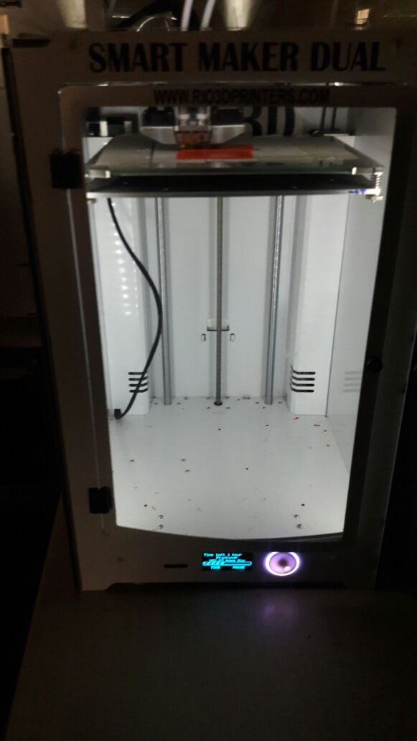 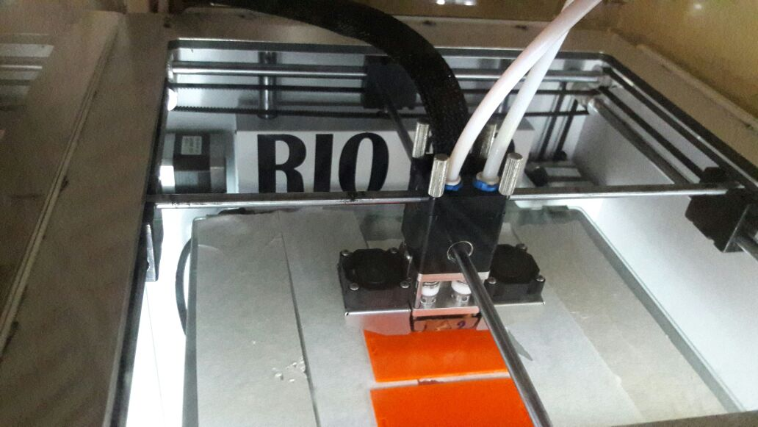

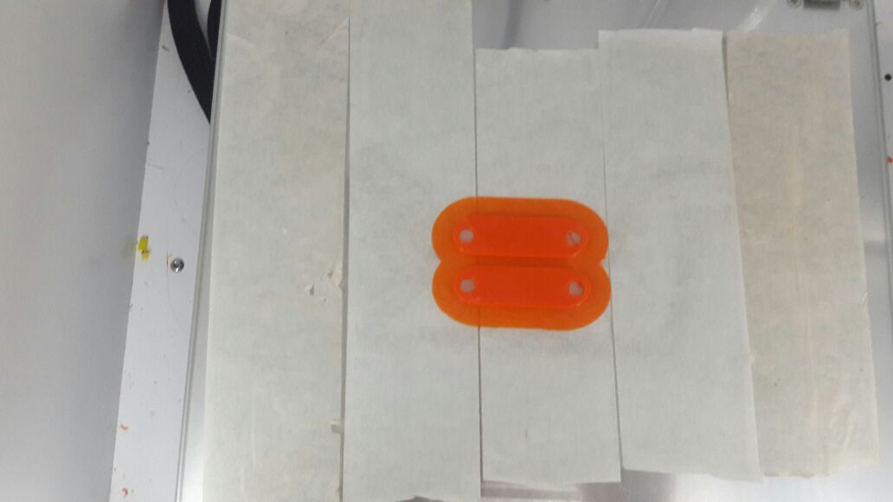 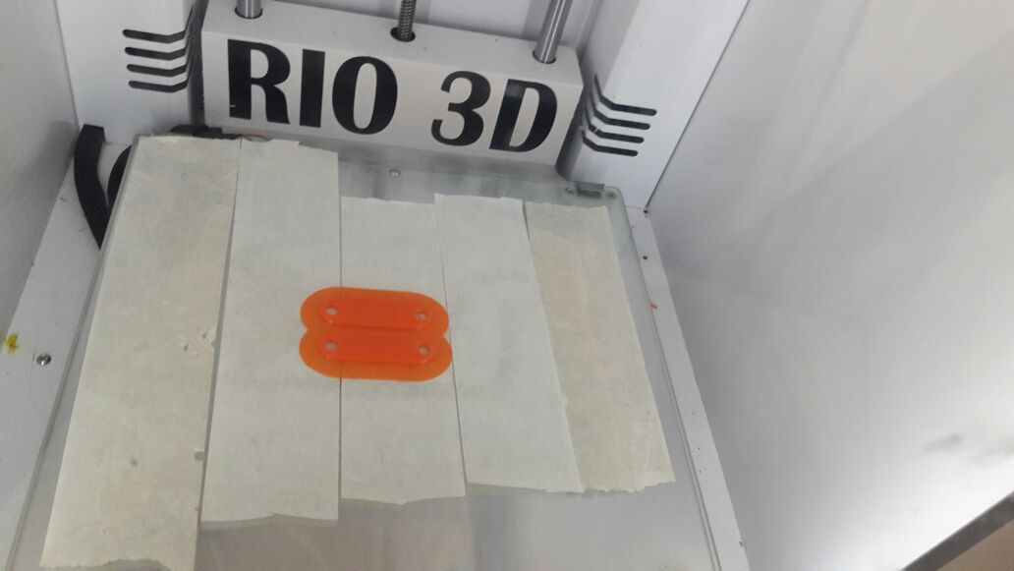

**5.3 Post Processing:**

In this process cleaning and finishing is given to the product (prototype). After manufacturing done in 3D printer, if the model have some holes or rib then in the 3D printing process the support is created automatically thus the support have to be removed by filing , cleaning or finishing the 3D model. The cleaning or finishing can be done in workshop by the use of smooth filers.

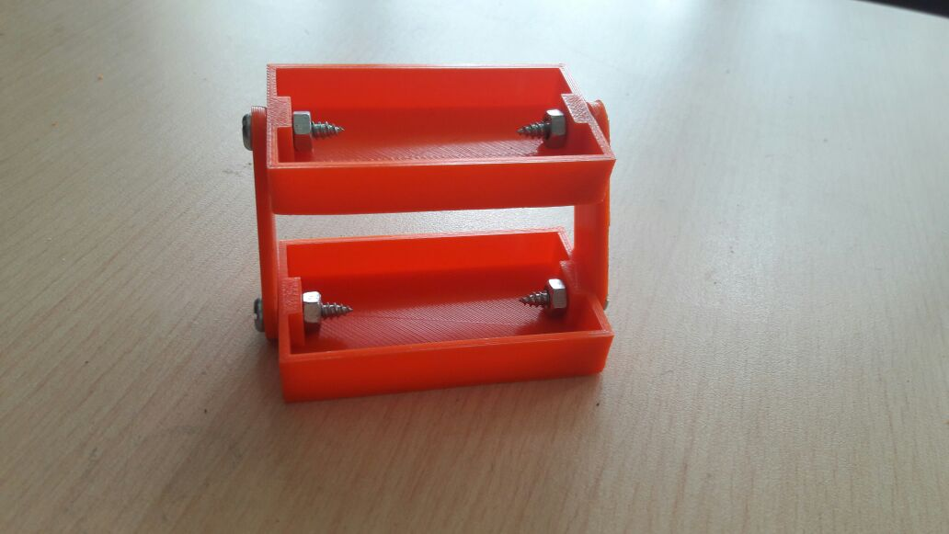

**6. Materials of 3D printing Machine:**

In 3D printing method there are various materials used according to the requirement of product, cost, etc. There are 3 most widely used materials which are **ABS**, **PLA** and **PVA.**

**6.1 ABS** **(Acrylonitrile Butadiene S1tyrene):**

AB﻿S is used in a very large variety of applications in the industry nowadays. ABS is generally very durable and strong, slightly flexible and quite resistant to heat. 3D printers able to process ABS plastics normally operate with a hot end, the heated part melting the plastic, before it’s forced through the print nozzle at a temperature around 210-250°C. Therefore, a 3D printer able to process ABS is necessarily equipped with a heated print bed, in order to prevent warping or cracking of the printed materials. When it comes to cost, ABS is the cheapest plastic of the three filament types.

But ABS also has some drawbacks. First of all, it is a petroleum-based non-biodegradable plastic. Another problem is that ABS does create (mild) fumes which may irritate more sensitive persons – an installation of the printer in a well-ventilated area or even a specific fume hood may be necessary.

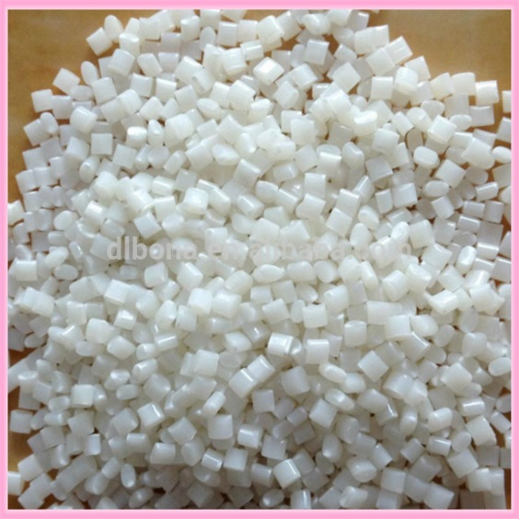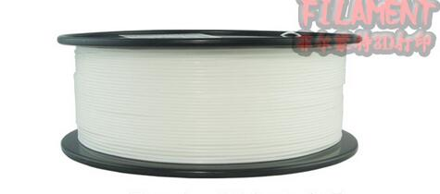

**6.2 PLA (Polylactic Acid):**

PLA is tough, but a little brittle, once it has cooled down. Its temperature threshold is lower than the one of ABS, as PLA is normally extruded around 160°C-220°C. A heated print bed is not mandatory, but it may (at temperatures around 50-60°C) be beneficial to the quality of the printed object. PLA is quite slow to cool. PLA is a biodegradable thermoplastic which is derived from renewable resources. This makes of PLA the most environmentally friendly solution in the domain of 3D printing.

Its main drawbacks are that it cannot stand too much heat, as standard PLA becomes soft around 50°C. Hence PLA is used in food packaging, bags, disposable tableware, upholstery, disposable garments, hygiene products and even diapers.

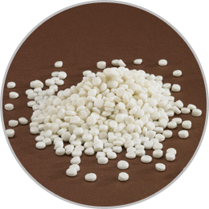 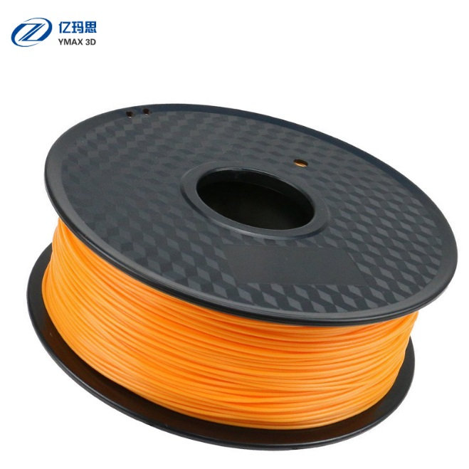

**6.3 PVA (Polyvinyl Alcohol):**

PVA is a special plastic that is water-soluble**.** In 3D printing, PVA is normally extruded a temperature of 190°C, but is not very easy to use, as it attracts water so much. Ambient air moisture will deteriorate the filament very quickly. PVA needs to be stored in a sealed box or container together and may need to be dried before use.

PVA is sometimes used in printers with dual or multiple-extruders, in order to provide a support structure to an object with overhangissues.

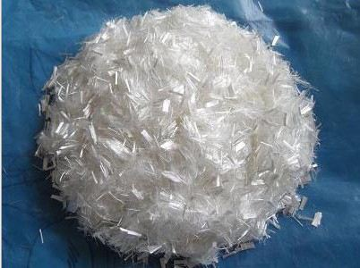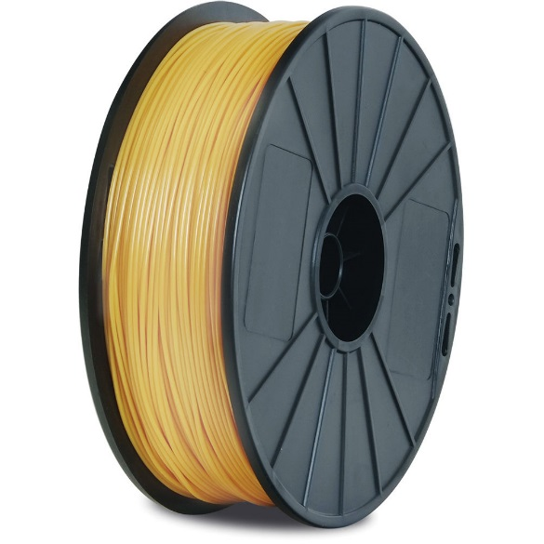

**7. Applications:**

We have designed a product with the help of cantilever mechanism used in day to day life

The model made by us is going to be multipurpose use, according to the requirement of user such as:

* Shoe rack
* Study & Coffee table
* Book rack
* Make up kit
* Mechanical’s tool kit
* Doctor’s kit
* Vegetable trolley

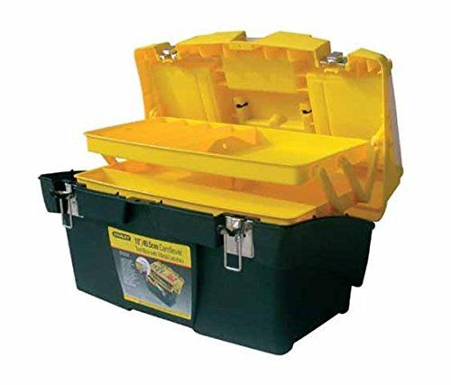 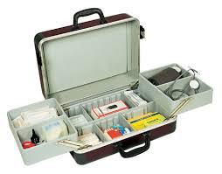

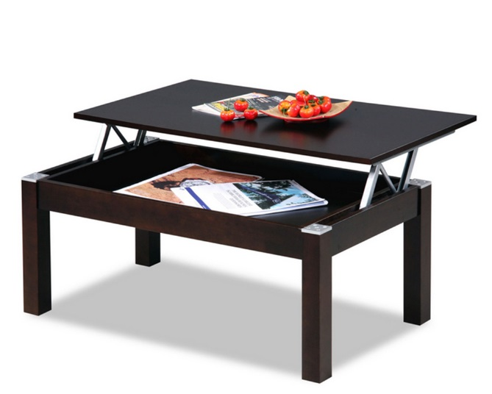 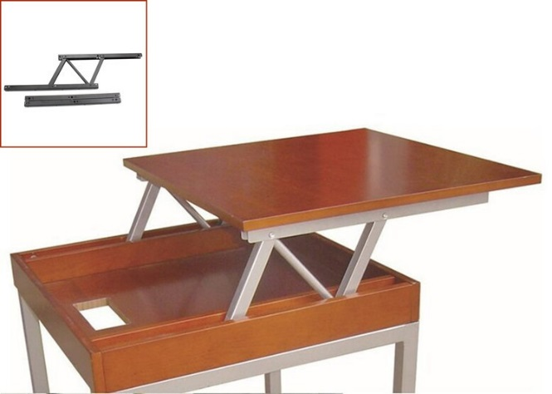

1. **Bill of material:**

|  |  |  |
| --- | --- | --- |
| Bill Criteria | Rate | Cost |
| Material | Rs 1.4/g | Rs 42 |
| Designing |  | Rs 200/product |
| Labor cost | Rs 50/hour | Rs 150 |
| Machine Rent and maintenance | Rs 50/hour | Rs 175 |
| Electricity Cost | Rs 9/Unit | Rs 18 |
| Total Cost |  | Rs 585 |

1. **Conclusion:**

We studied rapid prototyping process, 3D printing process, Basic about Catia software, cantilever mechanism.